**SGA How to test a drug**

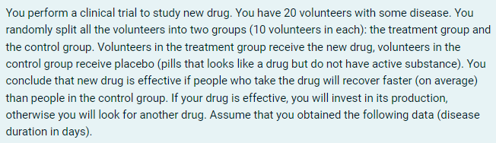

Control group (sample 0): (6, 7, 7, 5, 7, 8, 8, 7, 7, 7)

Treatment group (sample 1): (7, 6, 6, 5, 5, 6, 7, 5, 5, 8)

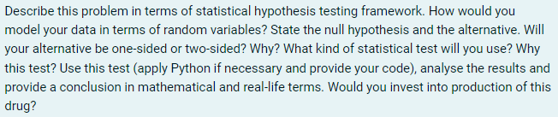

We can assume that data we’ve obtained are samples of two different random variables $X$ (sample 0) and $Y$ (sample 1).

$\overline{x}=6.9$ is mean of sample 0;

$\overline{y}=6$ is mean of sample 1.

At first glance it seems that $\overline{x}>\overline{y}$, so we might assume that $EX>EY$ and try to check such a hypothesis. But we shouldn’t state hypothesis on the data we use to test it.

As such, the first thing we actually should check is if there is any significant difference between expected values of $X$ and $Y$ at all based on these samples.

So null hypothesis would be that there is no significant difference, while alternative hypothesis would be that expected values of $X$ and $Y$ do differ significantly.

$$H_{0}:EX=EY$$

$$H_{1}:EX≠EY$$

We have two samples of data, so we have to use two-sample t-test to test our hypothesis. We can’t use paired t-test as there is no common ground for these two samples.

Also, there is no information suggesting that random variables $X$ and $Y$ have same variance, so in this test we will assume that $VarX$ and $VarY$ are different.

As this is related to healthcare, we want our chance of making mistakes (type I errors) as small as possible, so we should set significance level at $α=0.01$ at most.

Here is Python code to calculate the p-value of our t-test:

sample0 = (6, 7, 7, 5, 7, 8, 8, 7, 7, 7)

sample1 = (7, 6, 6, 5, 5, 6, 7, 5, 5, 8)

t_stat, pvalue = ttest_ind(sample0, sample1, equal_var=False, alternative='two-sided')

print(f'p-value is {pvalue}')

We get **p-value** equal to ***0.052905708062698176***.

As p-value is larger than $α$, there is no reason to reject $H_{0}$. Actually, the p-value we’ve got is much higher than I’d want it to be in case of drugs testing, we would reject $H_{1}$ even at significance level of 0.05.

This means that we don’t have enough data to reject $H_{0}$ in favor of $H_{1}$.

At the same time, it doesn’t mean, that $H_{0}$ is true. It might be that we just have insufficient data to accept alternative hypothesis over $H_{0}$, for example, we might get different results if we had larger samples of data for both control and testing group.

Still, considering results of this test, there is no reason to believe that new drug is effective. As such, there is no reason to invest into its production. At least until it was proven effective after more testing on other data samples.